Hello there,
During the latest testing, we came across the following observations.
- Please ensure that the game uses the rgs_url parameter to determine the server. When the rgs_url is invalid or changed to an incorrect value, the game should not be playable and only an appropriate “Failed to fetch” error message should be displayed, without any unnecessary technical details or code.
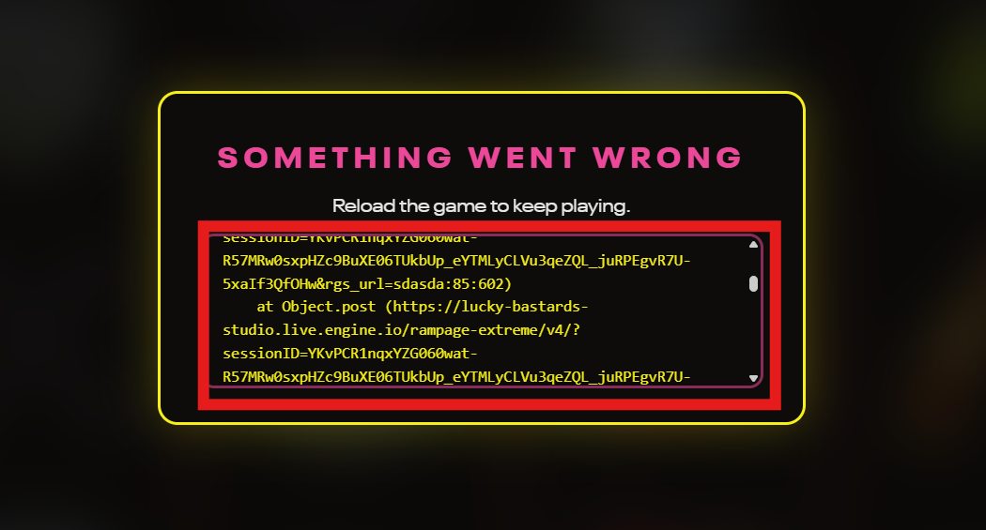

- Please make sure that the 16:9 tile is generally bright and does not clash with the Stake background. It is currently too dark.
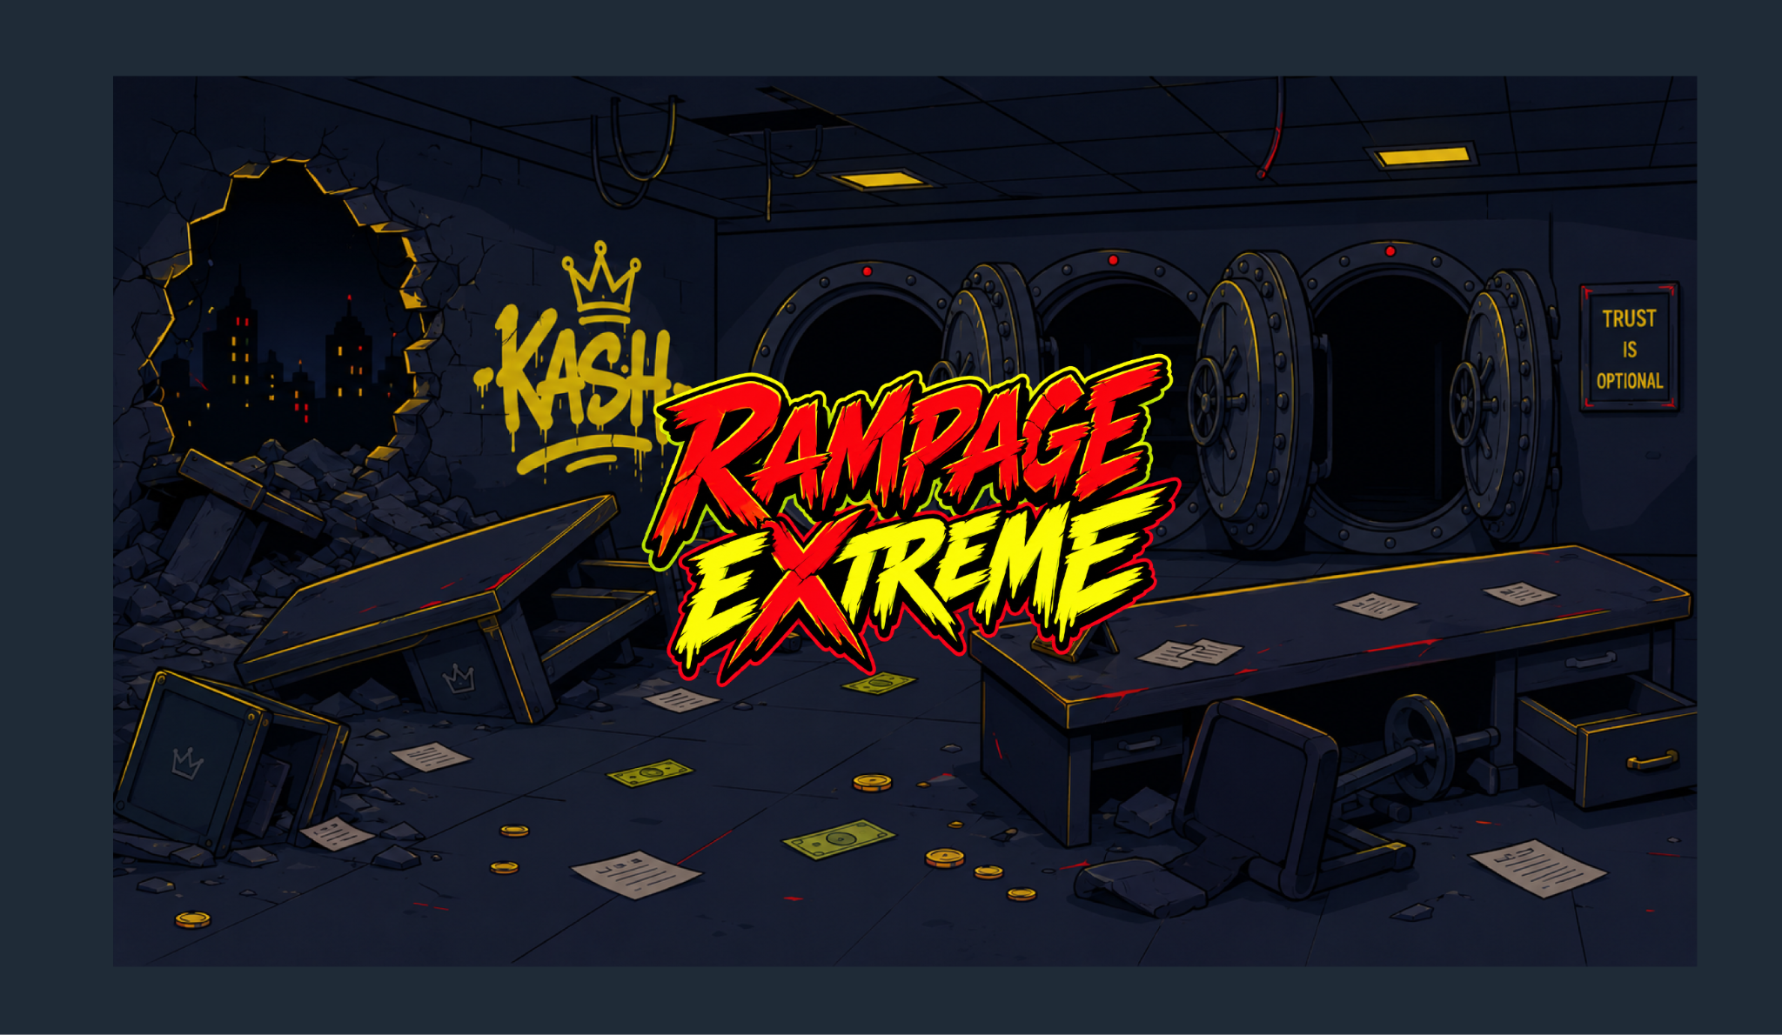

- Please make sure that the Game Info contains a description for each available game mode.

- Please make sure you use the official disclaimer from the documentation. https://studio.engine.io/docs/approval-guidelines/general-disclaimer
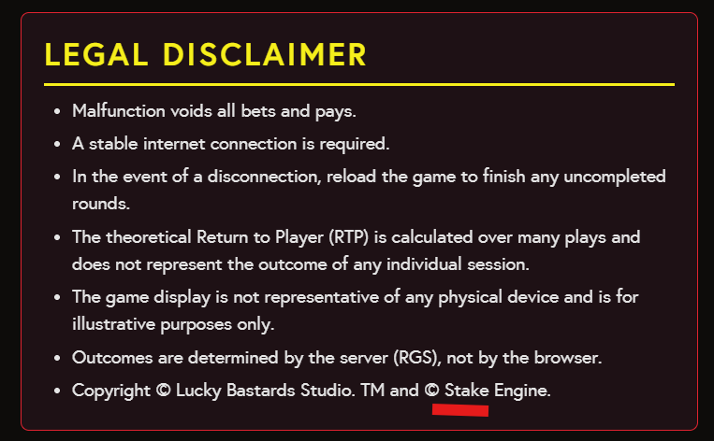
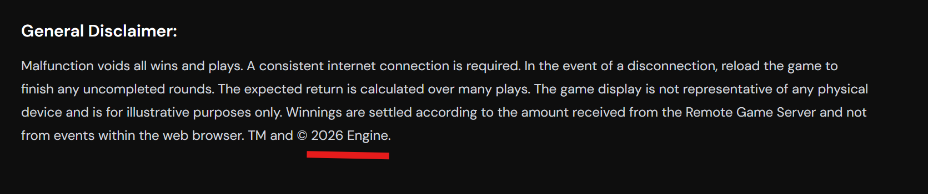

- Spanish text appears in the English translation.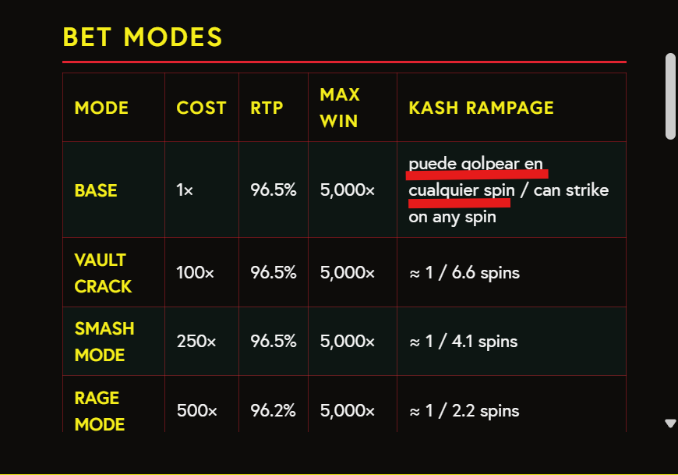

- Please make sure that no restricted words appear in social mode, and that all jurisdiction requirements are fully respected ( Documentation: https://stake-engine.com/docs/approval-guidelines/jurisdiction-requirements)
